**Strategic Product Placement Analysis: Unveiling Sales Impact with Tableau Visualization**

This project aims to investigate the relationship between product positioning, sales performance, and consumer behavior. Using Tableau, we will analyze data to uncover insights into how different positioning strategies impact sales and consumer preferences. By visualizing the data, we aim to provide actionable recommendations to optimize product positioning strategies and drive revenue growth.

A retail company wants to understand the impact of product positioning on its sales and consumer behavior. They have collected data on sales figures, product placement, and consumer demographics. They seek insights into which product positioning strategies are most effective in driving sales and how they can tailor their marketing efforts accordingly. Through data visualization with Tableau, the company hopes to gain actionable insights to improve its product positioning strategies and increase revenue.

Scenario 1. Film and Television Production Companies: Production companies can utilize strategic product placement analysis to optimize revenue generation through partnerships with brands. By employing Tableau visualization, they can analyze the effectiveness of product placements in different scenes or episodes. This analysis can help them negotiate better deals with brands, understand audience engagement with specific products, and make data-driven decisions on future placement opportunities.

Scenario 2. Retail and Consumer Goods Companies: Retailers and consumer goods companies can leverage strategic product placement analysis to enhance their marketing strategies and boost sales. By using Tableau visualization, they can track the performance of products placed in various locations within their stores or on their websites. They can identify high-traffic areas, understand customer preferences, and optimize product placement to increase visibility and drive conversions.

Scenario 3. Advertising Agencies: Advertising agencies can benefit from strategic product placement analysis to provide valuable insights to their clients and optimize advertising campaigns. By utilizing Tableau visualization, they can analyze the impact of product placements in different media channels such as movies, TV shows, or online videos. This analysis can help them demonstrate the ROI of product placement initiatives, refine targeting strategies, and improve campaign effectiveness for their clients.

**Technical Architecture**

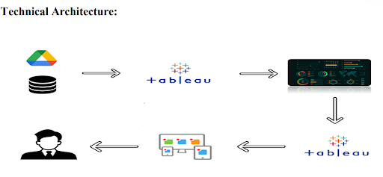

**Project Flow**

To accomplish this, we have to complete all the activities listed below,

?   Data Collection & Extraction from Database

o   Collect the dataset

o   Connect data with Tableau

?    Data Preparation

o   Prepare the Data for Visualization

?    Data Visualizations

o   No of Unique Visualizations

?    Dashboard

o   Responsive and Design of Dashboard

?    Story

o   No of Scenes of Story

?    Performance Testing

o   Utilization of Data Filters

o   No of Calculation Fields

o   No of Visualizations/ Graphs

?   Web Integration

o   Dashboard and Story embed with UI With Flask

?    Project Demonstration & Documentation

o   Record explanation Video for project end-to-end solution

o   Project Documentation-Step step-by-step project development procedure

**Data Collection and Extraction of Data**

Data collection is the process of gathering and measuring information on variables of interest, in an established systematic fashion that enables one to answer stated research questions, test hypotheses, and evaluate outcomes, and generate insights from the data.

**Collect the dataset**

Please use the link to download the dataset:  
  
<https://www.kaggle.com/datasets/amitvkulkarni/impact-of-product-positioning-on-sales>

**Understanding the Data**

The dataset includes information on sales data, product positioning, and consumer behavior metrics. It contains variables such as product placement (endcap, aisle, shelf), sales revenue, customer demographics, product attributes, and promotional activities. The dataset covers a range of products and periods, allowing for a comprehensive analysis of the impact of product positioning on sales and consumer behavior.

1. Product ID: A unique identifier assigned to each product in the dataset.
2. Product Position: The relative placement or ranking of the product within its category(endcap, aisle, shelf)of the market.
3. Price: The selling price of the product.
4. Competitor's Price: The price at which competitors are selling a similar product.
5. Promotion: Any special offers, discounts, or promotions associated with the product.
6. Foot Traffic: The volume of people passing by or visiting the location where the product is sold.
7. Consumer Demographics: Characteristics and traits of the target audience (Families, Seniors, Young adults, and College students) or consumers purchasing the product.
8. Product Category: The broad category or type of product to which it belongs.
9. Seasonal: Indicates whether the product is seasonal or not seasonal.
10. Sales Volume: The quantity of units sold for the product over a specific period.

### Connecting the dataset with Tableau

To visualize the dataset in Tableau, import the dataset file into Tableau Desktop. Then, link the relevant columns to Tableau's data fields to create visualizations and analyze the data effectively.

ReferenceVideo:   
<https://drive.google.com/file/d/1cS7Ork8XG7c_RjdmMW_EwZqQj6cwgn9x/view?usp=sharing>

**Data Preparation**

Preparing data for visualization is a crucial step in the data analysis pipeline, involving various tasks to ensure the quality and usability of the dataset. Initially, cleaning the data is essential, which entails identifying and removing irrelevant or missing data points that could skew the analysis. Transforming the data into a format conducive to visualization involves organizing it in a structured manner, standardizing units of measurement, and converting categorical variables into numerical ones where necessary.

**Prepare the Data for Visualization**

Exploring the data is another vital aspect of preparation, where analysts delve into the dataset to uncover underlying patterns, trends, and relationships among variables. This exploration aids in determining which aspects of the data are most relevant for visualization and analysis. Filtering the data allows analysts to focus on specific subsets or segments of the dataset, refining the scope of analysis and visualization to address particular questions or objectives.

Once the data is cleaned, transformed, explored, and filtered, it is prepared for integration into visualization software such as Tableau. This involves formatting the data according to the requirements of the software and ensuring compatibility with the chosen visualization techniques. Additionally, ensuring the accuracy and completeness of the data is paramount throughout the preparation process, as any inaccuracies or omissions could lead to erroneous conclusions during analysis.

**Data Visualization**

* Data visualization is the process of creating graphical representations of data in order to help people understand and explore the information. The goal of data visualization is to make complex data sets more accessible, intuitive, and easier to interpret. By using visual elements such as charts, graphs, and maps, data visualizations can help people quickly identify patterns, trends, and outliers in the data.

### No of Unique Visualizations

The number of unique visualizations that can be created with a given dataset. Some common types of visualizations that can be used to analyze the performance and efficiency of Product Placement include bar charts, Stacked Bar charts, heat maps, Donut charts, Bubble charts, pie charts, etc. These visualizations can be used to compare performance, track changes over time, and show distribution, and relationships between variables, such as revenue and customer demographics, Competitors' price, Product Category, Product Position, Season, and Promotion.

Activity 1.1: Avg Sales Volume vs Product Category

Explanation Video Link:

<https://drive.google.com/file/d/1U7VKPbMDP1aTYd1KLdk284DZGPgJXkQF/view?usp=drive_link>

Activity 1.2: Competitor Price Vs Price

Explanation Video Link:

<https://drive.google.com/file/d/1mzcXYYd1Sv3WXWnt8fzqkpCC5c9M3MPM/view?usp=drive_link>

Activity 1.3: Avg Sales Volume by Product Category by Product Position

Explanation Video Link:

<https://drive.google.com/file/d/1HBeHTh_XHriqfFR7dsJTP-jTPuEyS9fV/view?usp=drive_link>

Activity 1.4: Consumer Demographics vs  Sales Volume

Explanation Video Link:

<https://drive.google.com/file/d/1laY_qirn7JN1kTGs3bVKEpl1085pYHmr/view?usp=drive_link>

Activity 1.5: Product Category vs Price

Explanation Video Link:

<https://drive.google.com/file/d/1-BUwN1kuJguZ6eQV6vvT6g9ysZxYx4cY/view?usp=drive_link>

Activity 1.6: Avg Sales Volume by Product Category by Season

Explanation Video Link:

<https://drive.google.com/file/d/12E_h12OOvQuHBoknh19e8MIBvLKs8ySq/view?usp=drive_link>

Activity 1.7: Foot Traffic  by Avg Sales Volume

Explanation Video Link:

<https://drive.google.com/file/d/17PbnYEKHEfuzOFBLhp9pTz9UkhYoZd1S/view?usp=drive_link>

Activity 1.8: Promotion of Product Category on Price and Sales Volume

Explanation Video Link:

<https://drive.google.com/file/d/1N-BwMnpxj87BrH86GpBwn5W_z8MxWEaV/view?usp=drive_link>

**Dashboard**

A dashboard is a graphical user interface (GUI) that displays information and data in an organized, easy-to-read format. Dashboards are often used to provide real-time monitoring and analysis of data and are typically designed for a specific purpose or use case. Dashboards can be used in a variety of settings, such as business, finance, manufacturing, healthcare, and many other industries. They can be used to track key performance indicators (KPIs), monitor performance metrics, and display data in charts, graphs, and tables.

**Responsive and Design of Dashboard**

The responsiveness and design of a dashboard for analyzing the performance and efficiency of Product Placement is crucial to ensure that the information is easily understandable and actionable. Key considerations for designing a responsive and effective dashboard include user-centered design, clear and concise information, interactivity, data-driven approach, accessibility, customization, and security. The goal is to create a dashboard that is user-friendly, interactive, and data-driven, providing actionable insights to improve the performance and efficiency of Product Placement Analysis.

Once you have created views on different sheets in Tableau, you can pull them into a dashboard.

Explanation Video Link:

<https://drive.google.com/file/d/1u67ecEyQz7XswgekZnpdHAE5sEhy79rS/view?usp=drive_link>

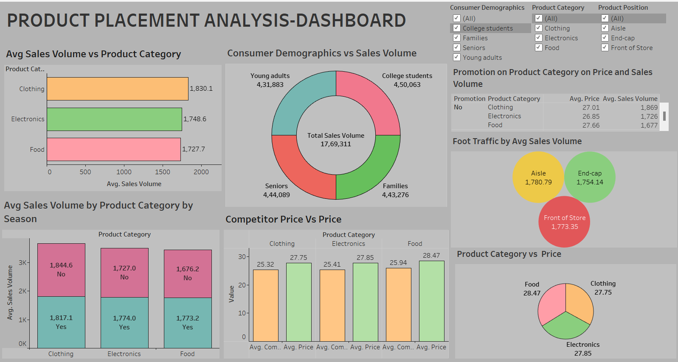

**Story**

A data story is a way of presenting data and analysis in a narrative format, intending to make the information more engaging and easier to understand. A data story typically includes a clear introduction that sets the stage and explains the context for the data, a body that presents the data and analysis logically and systematically, and a conclusion that summarizes the key findings and highlights their implications. Data stories can be told using a variety of mediums, such as reports, presentations, interactive visualizations, and videos.

**No of Scenes of Story**

The number of scenes in a storyboard for a data visualization analysis of the performance and efficiency of Product Placement will depend on the complexity of the analysis and the specific insights that are trying to be conveyed. A storyboard is a visual representation of the data analysis process and it breaks down the analysis into a series of steps or scenes.

Explanation Video Link:

<https://drive.google.com/file/d/15Q105EwhPRdJiEuYl6q9I7lxqZk8HYWo/view?usp=drive_link>

STORY SCENE-1

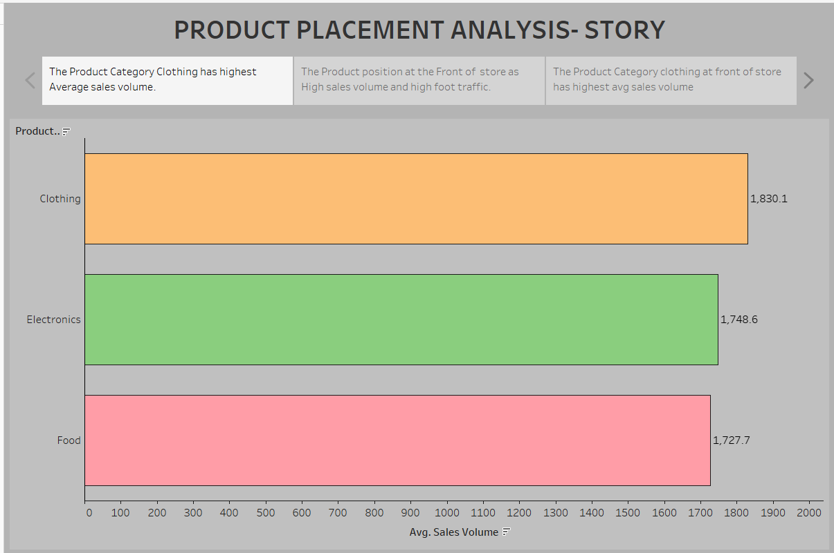

STORY SCENE-2

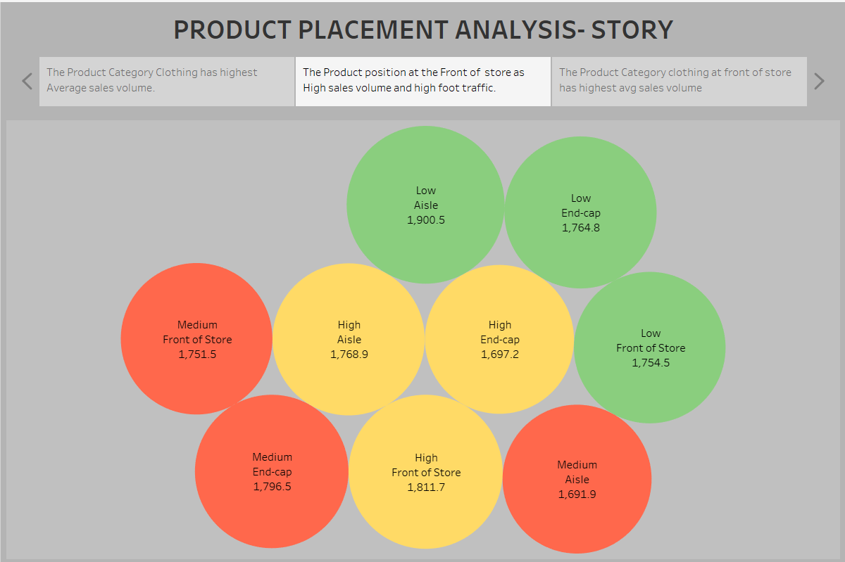

STORY SCENE-3

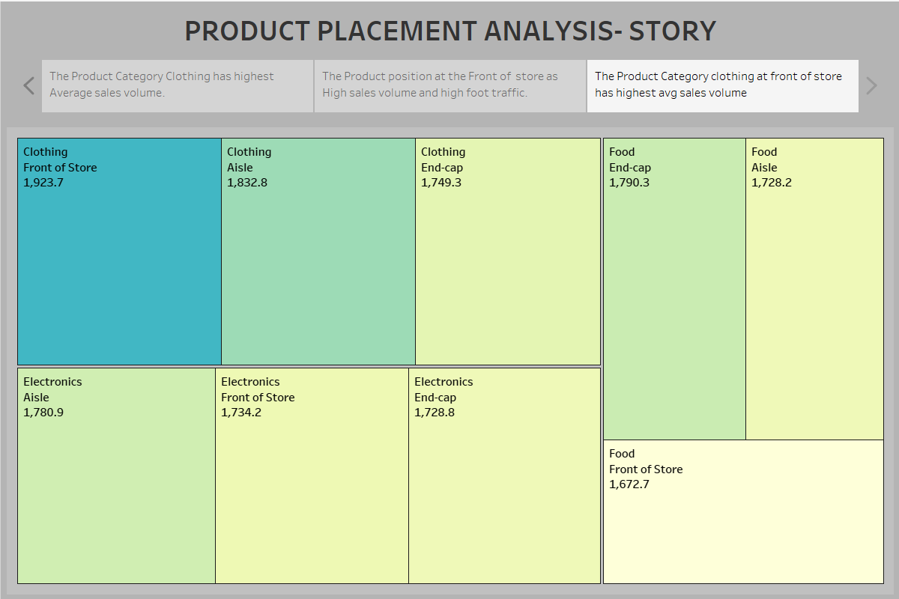

**Performance Testing**

Performance testing is a crucial aspect of software development aimed at evaluating the speed, responsiveness, stability, and scalability of an application under various workload conditions. It involves simulating real-world usage scenarios to assess how the system behaves and performs under stress, peak loads, or normal conditions.

**Utilization of Filters**

1. Filters are an indispensable tool in data analysis and visualization, allowing users to refine and focus on specific subsets of data that are relevant to their analysis objectives.

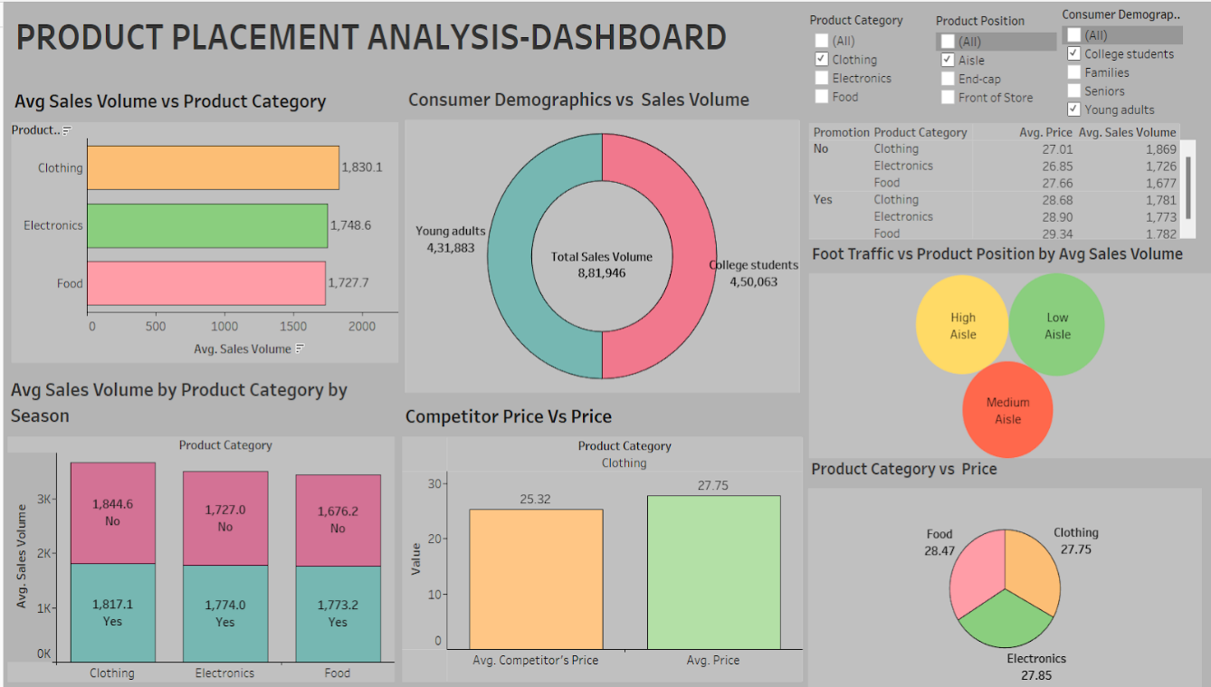

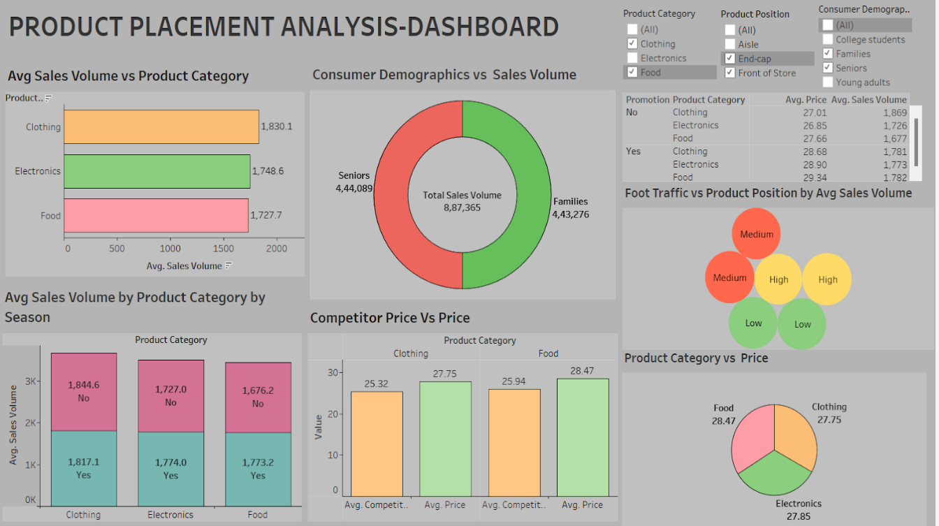

**No of Calculation Fields**

* Price
* Competitors Price
* Sales Volume

**No of Calculation Fields**

* Price
* Competitors Price
* Sales Volume

**Web integration**

Publishing helps us to track and monitor key performance metrics, to communicate results and progress. help a publisher stay informed, make better decisions, and communicate their performance to others.

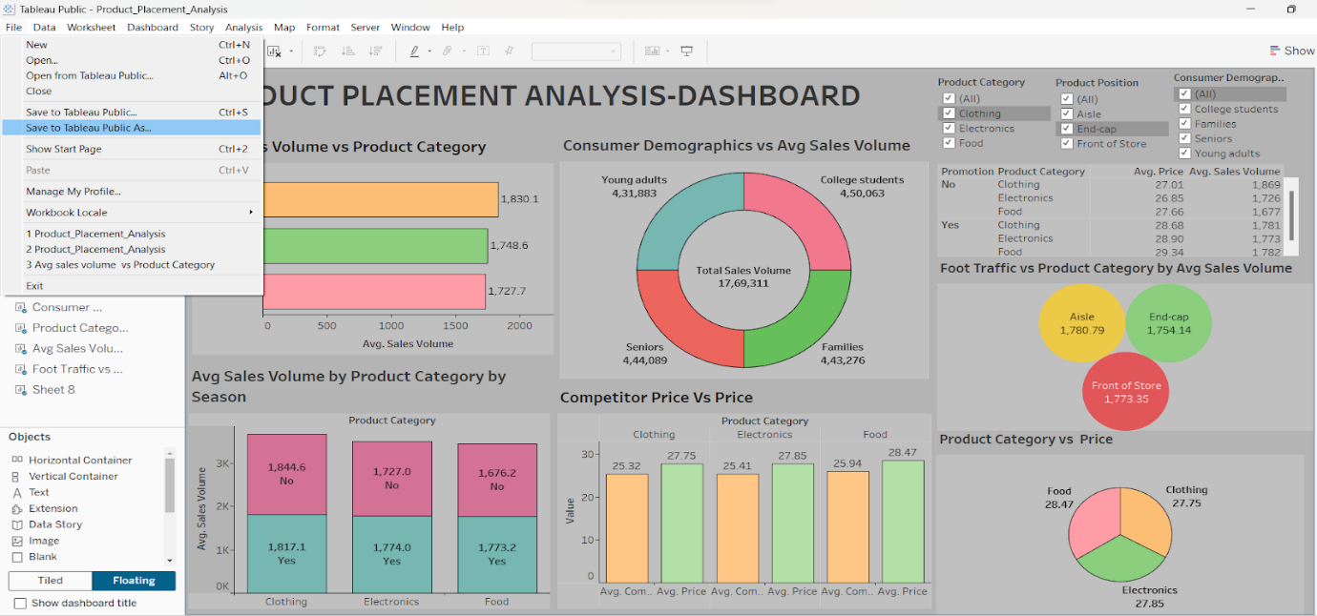

The above gives information on how to save and publish the dashboard to the tableau public.

* Click on  “File” which is displayed on the left top corner of the dashboard sheet.
* Now click on the Save as Tableau Public As option and that will redirect to your sign-in account as shown below.

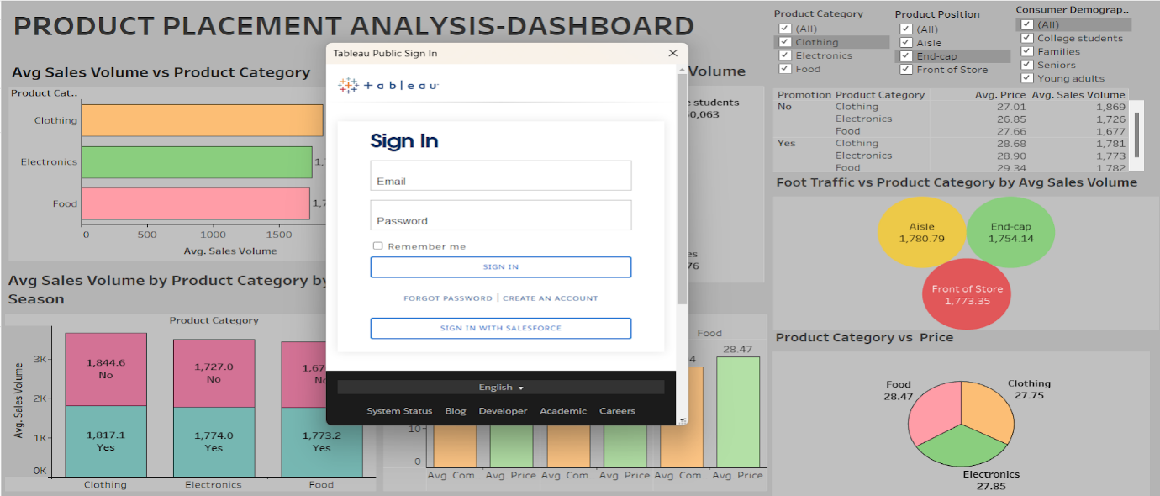

Now sign in to your Tableau public account and there your visualization, dashboard, and story are published. In this way, we can publish your dashboard and story into your tableau public.

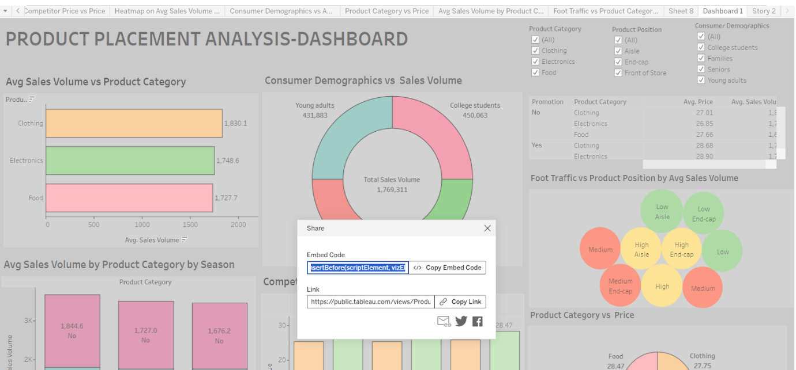

After signing into your public account the workbook is displayed. Now click on “settings” and then it will display to show sheets are disabled so enable it so, that all your sheets are visible.

Now click on the dashboard sheet in the top right corner we have an option called share click on it then it will show like the above screenshot. Then, copy the embedded code and place the copied embedded code into your bootstrap template as shown in the reference video below.

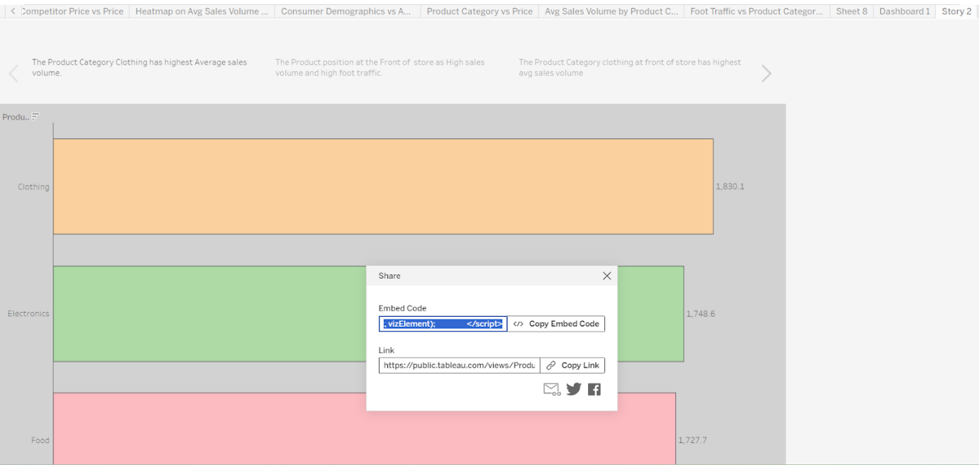

After copying the embedded code of the dashboard from Tableau Public and pasting it in the Bootstrap template then use the same procedure for the story also to copy the embedded code from the Tableau Public and paste it into the Bootstrap template.

**Dashboard and Story embed with UI With Flask**

Explanation Video Link:

<https://drive.google.com/file/d/1-ImErECS0qUz3dOHx901QKa5HXGTGkdl/view?usp=drive_link>

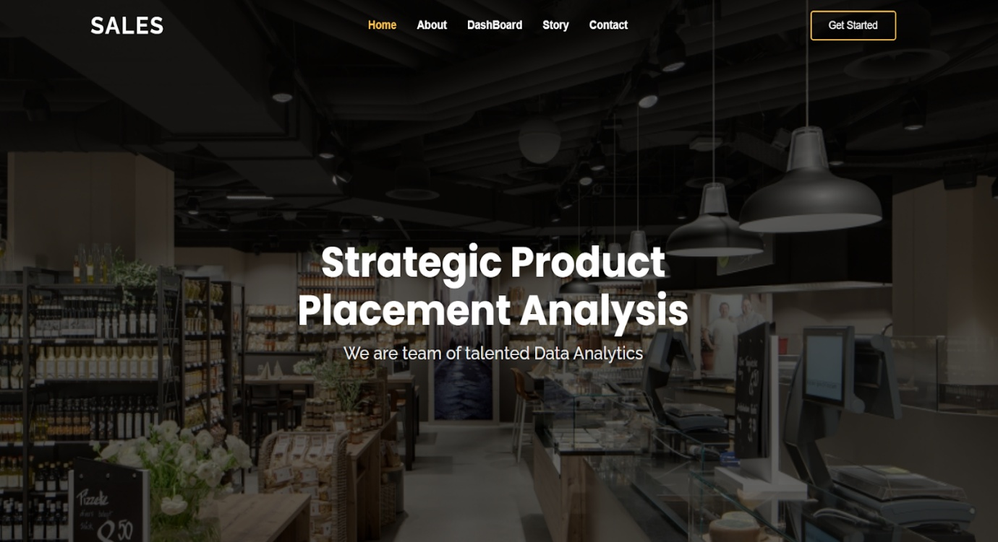

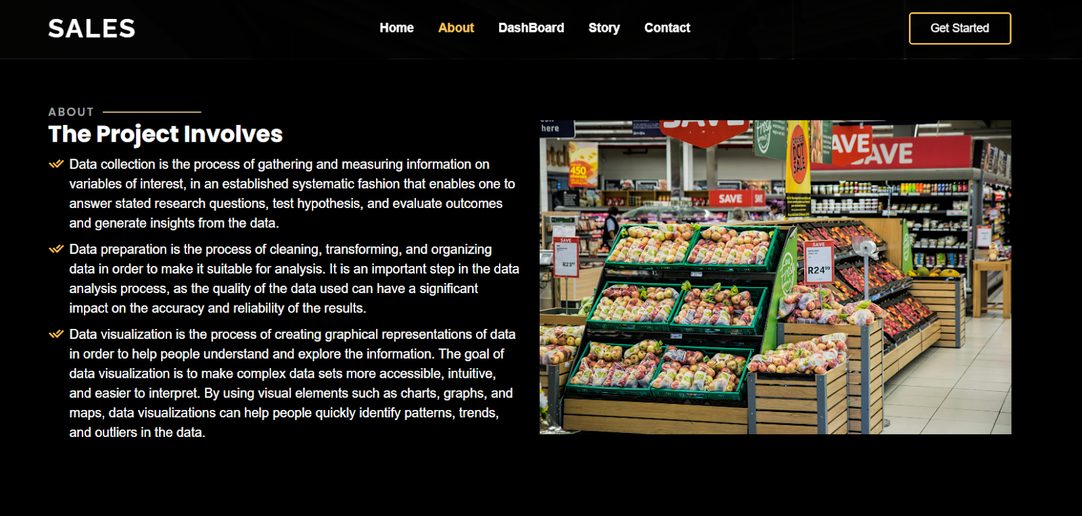

DASHBOARD

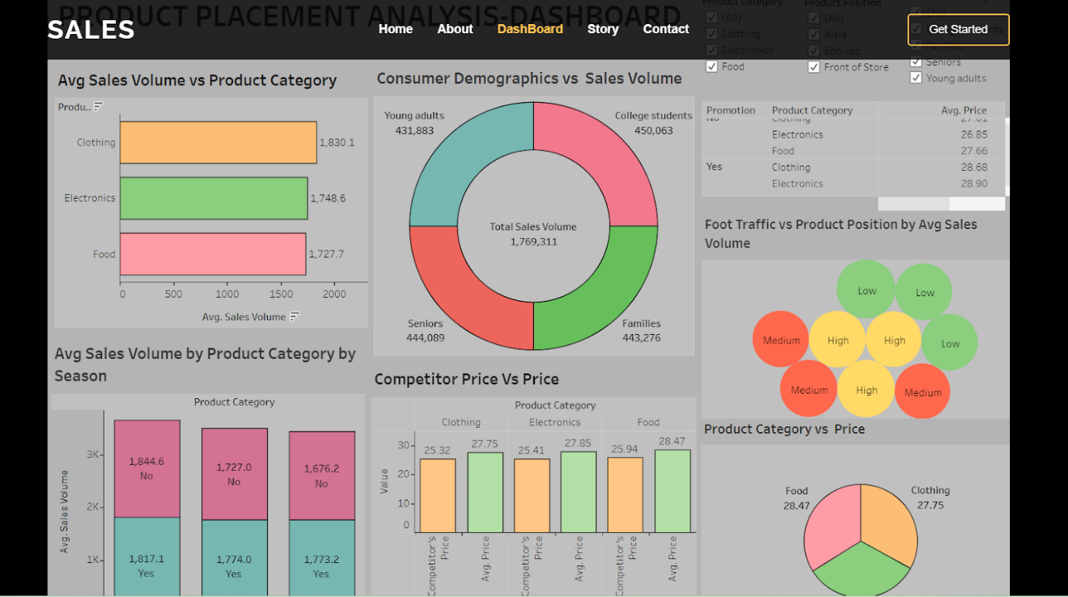

STORY SCENE-1

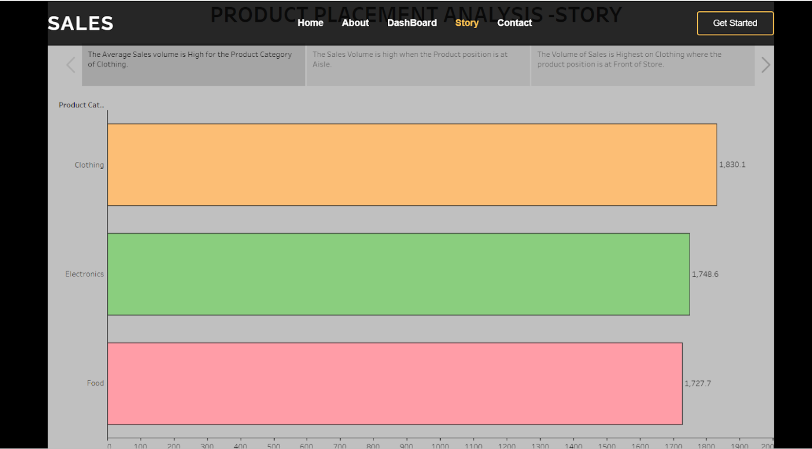

STORY SCENE-2

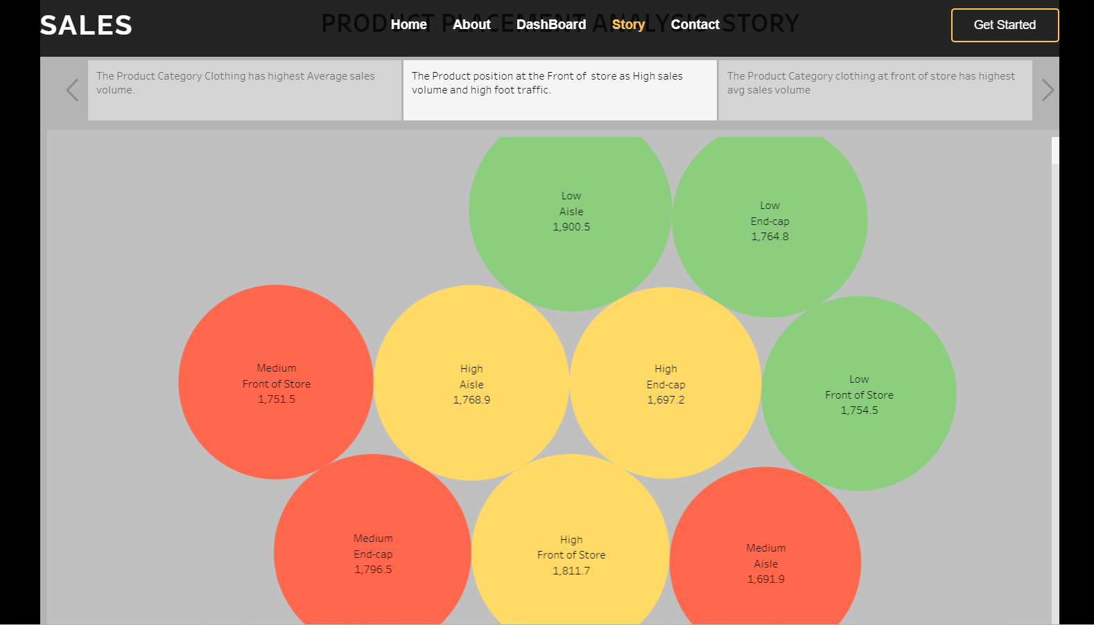

STORY SCENE-3

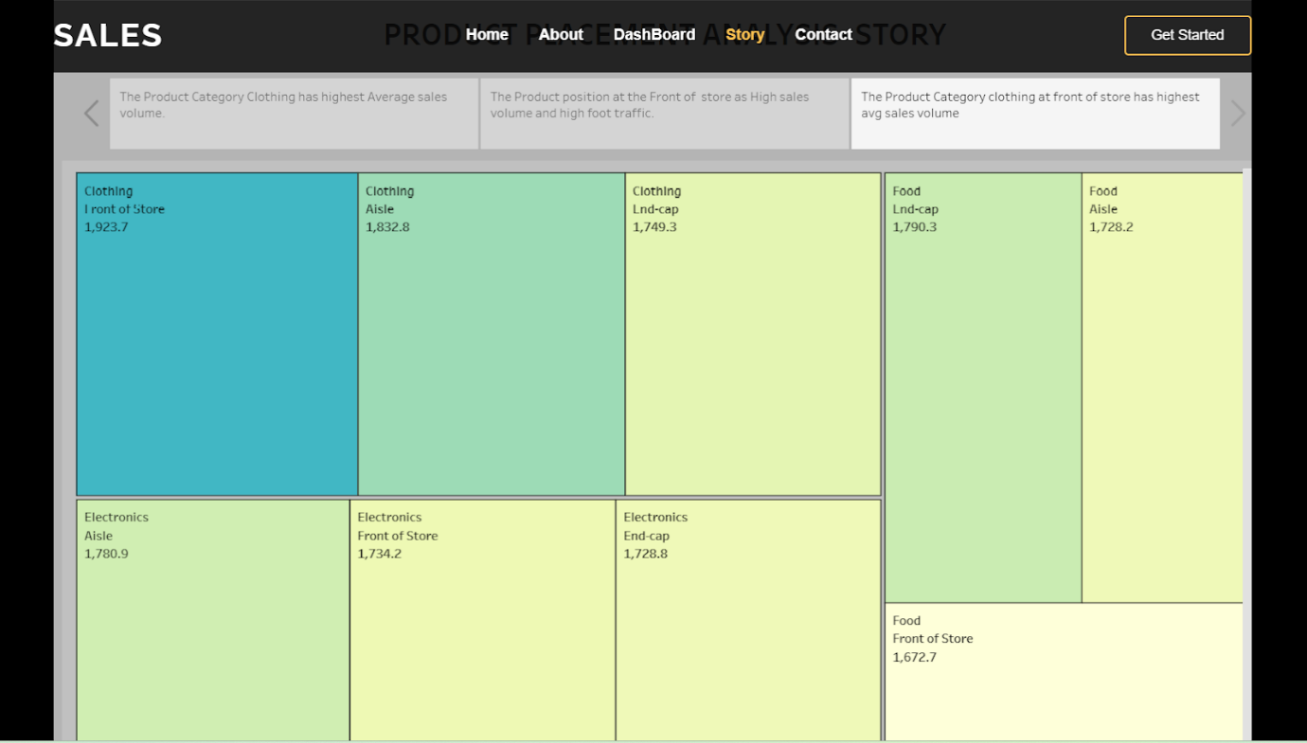

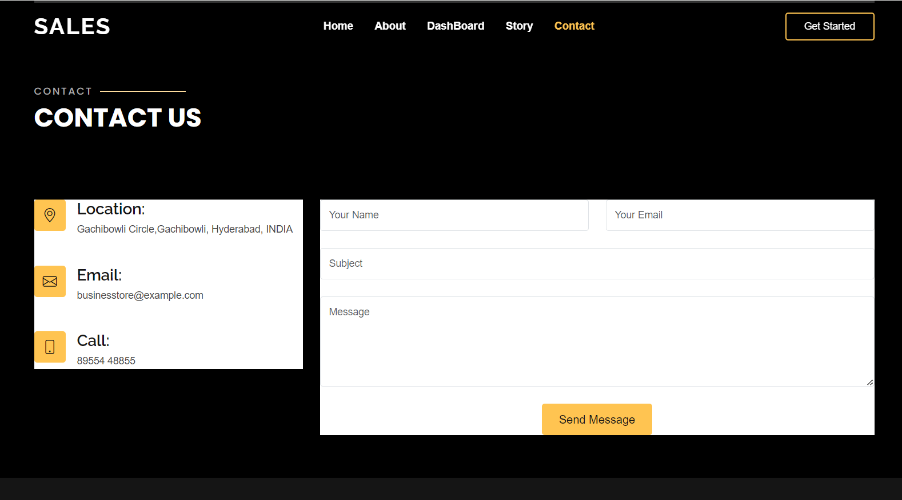

**Project Demonstration & Documentation**

The mentioned deliverables are to be submitted along with other deliverables